HISTORY OF ST. JOHN’S LUTHERAN CHURCH
WODEN, IOWA

St. John’s Lutheran Church of Woden, Iowa was formed in the vast prairie of northern Iowa toward the end of the 19th century. Woden was just beginning to be settled in 1893 when the rugged pioneers who had come to Iowa in quest of a new home began to gather to worship God, to hear His Word, to receive the sacraments, to sing, and to pray. Pastor Bernt had come to minister to the spiritual needs of the Lutheran people who had settled in this territory and was serving a congregation in Garner 25 miles from Woden. The roads in those years were very poor, the distance far, and the countryside bleak and barren. Because of these conditions, Pastor Bernt could only come to Woden as often as circumstances would permit. As the congregation did not have a suitable building in which to worship, services were held in people’s homes or in rural school houses.

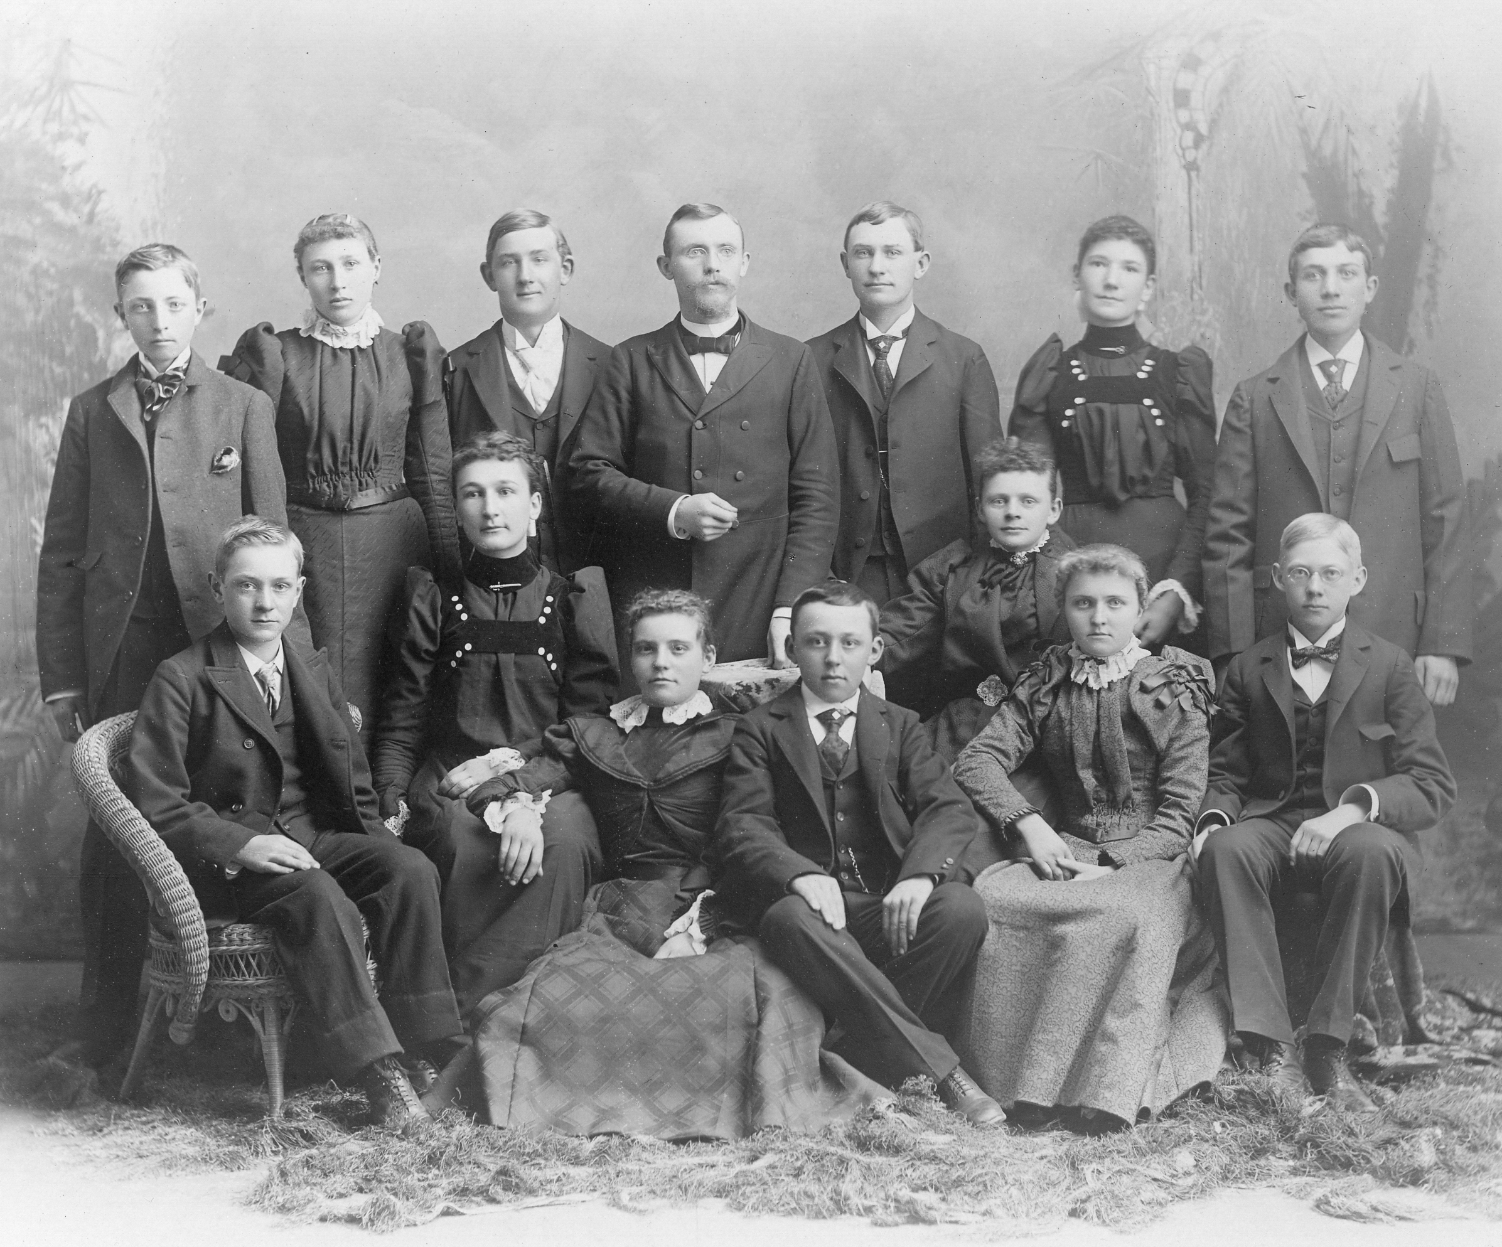
In 1895, the Reverend E.F.J. Richter succeeded Pastor Bernt and served the people of the community for the next 2 years. The Reverend M. Behrends from Plum Creek in Kossuth County was called to serve the group in Woden in 1897. His ministry at Woden lasted for seven years. On April 3, 1898, Pastor Behrends confirmed a small group from Woden at the Plum Creek Church near Algona, Iowa. That group included: Katie Miller, Louisa Miller, Amolie Kramer, Martin Kramer, Adele Boecker, and Dora Mussman.
1898 Confirmation Class

The first three pastors of St. John’s were affiliated with the Lutheran Church – Missouri Synod. At this particular time in history it was possible to have services only once every three weeks. The congregation at that time did not consider this an ideal arrangement and began to search for a way to have a pastor each Sunday to lead the congregation in worship.

In 1905, the infrequency of services caused a member of the congregation, Mr. Henry Baack, to discuss the matter with the Rev. August Wellner, who was serving Immanuel Lutheran Church of Titonka. As a result of those discussions, arrangements were made so that Pastor Wellner could conduct services at Woden each Sunday. The services were held Sunday afternoon at 1:30 pm in the Woden public school building. Pastor Wellner was affiliated with the former Ohio Synod which had merged with the American Lutheran Church. Two years later, on January 4, 1907, a meeting was held to consider the possibility of officially organizing the congregation at Woden. During the meeting a constitution was proposed and Mr. Henry Baack was elected chairman to preside at a later meeting. On March 3, 1908 a committee voted to change from affiliation with the Missouri Synod to the Augsburg Confession. The constitution was adopted and signed and St. John’s Lutheran Church was born. The charter members were: Mr. Henry Baack, Mr. John Baack, Mr. Fredrick Gerdes, Mr. Jerry Ranger, Mr. Otto Kramer, and Mr. Martin Kramer.

After the congregation was officially organized, services still had to be held in the public school building as they did not have a church building of their own. The school was a large building and centrally located so it was a good choice for holding worship services. Some members of the congregation were baptized in that school house before a church building was constructed in 1913. The first adult class confirmed after the official organization of St. John’s included: Mrs. Otto Kramer, John Buns, Albert Gerdes, Anna Gerdes, George Gerdes, John Gerdes, Peter Range and Maggie Range. This group was confirmed by Pastor Wellner on May 26, 1907. During the year of 1907 many new members joined the congregation and the little group, started some 14 years before, began to grow. Like the little kernel of mustard seed, St. John’s had taken root. This growth continued from year to year.

From the time the congregation had come into being there was a growing desire to own a church in which God could be worshipped in a more favorable environment. In 1908, this desire had become so intense that the congregation considered purchasing a church building which was for sale in Wesley, Iowa. However the price for the building was too high and the cost of moving it to Woden was prohibitive.

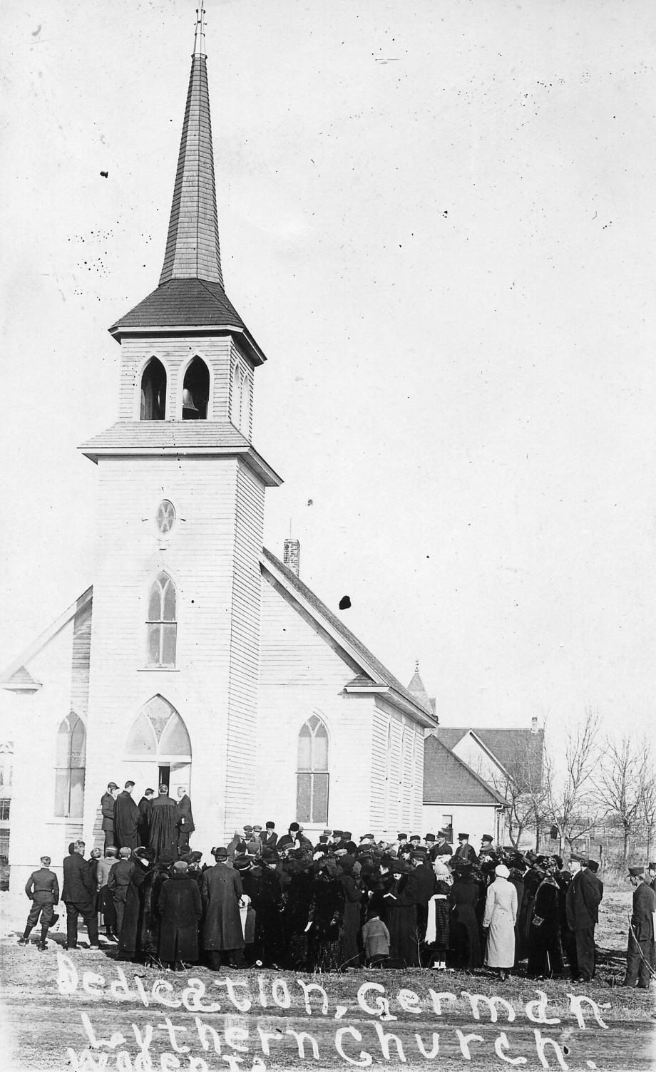
During the next five years, the congregation enjoyed consistent and encouraging growth. Of course with a growing membership, the desire to own a church home of its own was also growing. By this time, the members of the congregation no longer wanted to buy an old building, but longed for a new building. In a short time the opportunity for such a building presented itself. Mr. John Bode donated the lot on which the church was built, the necessary funds were soon gathered and the construction of the new building commenced. The actual cost for the erection of the building was $2,500 and when the building was completed the payment was made in cash.

There was much donated labor in the actual construction of the building and this effort kept the cost low. Three men supervised the construction work. They were Mr. Fritz T. Gerdes, Mr. Henry Baack, and Mr. Gustav Onken. The building of St. John’s Church was the second or third construction venture of Fritz Gerdes after arriving in America from his German homeland. The window frames in the church were all hand constructed and the twenty-four foot steeple was built in the entry way of the new building and lifted into place with a block and pulley. The Ladies Aid Society of the congregation provided money for the purchase of the pews and the organ. The baptismal font was given by Mr. and Mrs. John Boeker. The Rev. and Mrs. Wellner gave the church bell.
Dedication of St. John’s Lutheran Church 1913

The cornerstone for the new church building was laid on July 27, 1913 and the building was finished and dedicated on December 20, 1913. According to congregational history, Dr. Wilke (or a Dr. Meyer), the president of the Minnesota District, of which St John’s was then a part, preached the sermon that morning. The Rev. Wellner and another pastor assisted in the dedicatory rites. Two of the members of the congregation, Mr. Albert Gerdes and Mr. G. Saathoff, carried Bibles into the church on that great day. The first bible was placed on the altar and the second on the pulpit.

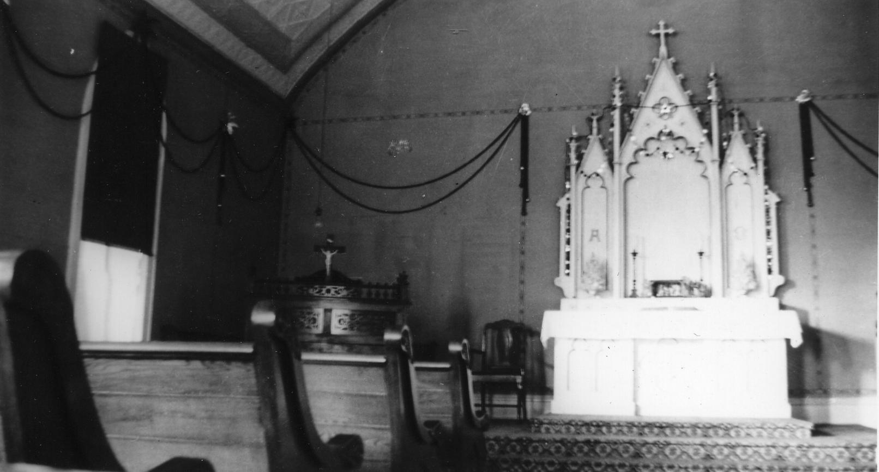
Following the dedication of the new church the congregation, along with its pastors, began the patient but consistent work of bringing the Word of God to the Lutherans of the community. Almighty God had blessed the congregation with growth, not only in numbers but more important in spirituality.

Pastor Wellner served the congregation until 1922. His successor was the Rev A.H. Kilian who served until 1931. Both of these ministers also served Immanuel Lutheran Church, northwest of Woden. After that time, St. John’s was served by ministers from First Lutheran in Britt, Iowa. The Rev. C. P. Ringhand served from 1931-1932 followed by the Reverend A. R. Wacholz who served from 1932-1935.
Interior of church

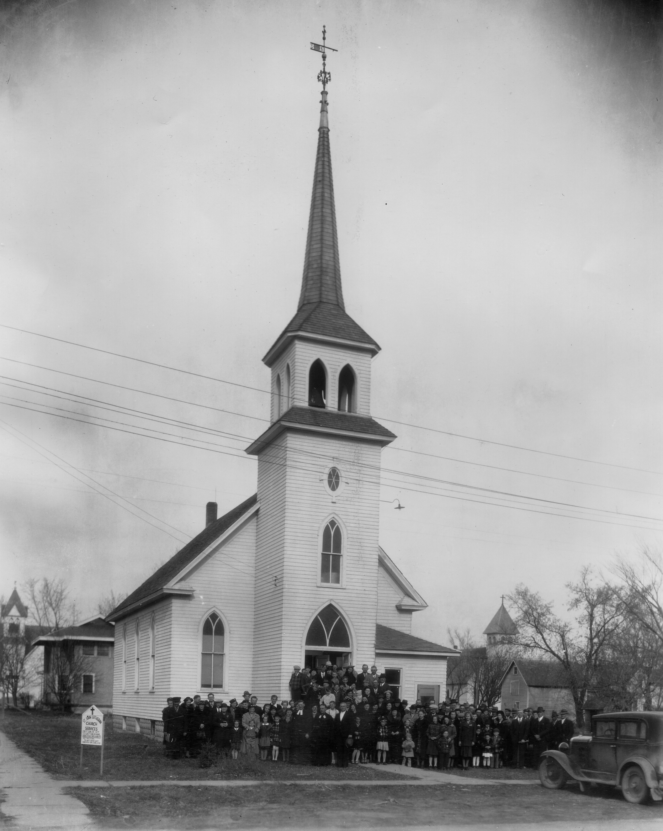
It was during the ministry of the Rev J. H. Kolberg who served from 1935-1942 that the congregation celebrated its silver anniversary. The actual service was held on Nov 20, 1938 but even in 1937, plans were made for improvements. The Ladies Aid Society agreed to pay 50% of the cost for the decoration of the interior of the church and to cover the ceiling with Nu-wood. The ornamental tin taken from the church ceiling was used to cover the ceiling in the basement. The congregation voted to match the 50% and to carry on with certain other improvements such as finishing the basement. The Luther League agreed to pay for the stairway leading from the narthex to the basement of the church. The Sunday school shared in the preparation too by agreeing to pay for the refinishing of the altar, the pulpit and the baptismal font.

The guest speakers on the anniversary Sunday were the Rev. A.R. Wacholz, Rev. A. H. Kilian and Rev. C. P. Ringhand, all former pastors at St. John’s. Three services were held that Sunday. A fellowship dinner was served during the noon hour by the Ladies Aid Society.
Silver Anniversary 1938

Five years later the congregation celebrated its thirtieth anniversary on Sunday, October 31, 1943. The Rev. C.P. Ringhand, a former pastor, spoke in the afternoon and again at the evening service. The Luther League with the assistance of the choir, presented a pageant entitled, “The Challenge of the Cross.” Greetings were brought from the neighboring pastors and congregations. The Rev. John Mohr, also from Britt, was the pastor from 1942 – January of 1944.

During the anniversary of 1943 the congregation was presented with an opportunity to fulfill its dream of owning a parsonage and having a resident pastor. During the summer months Mr. Herman Swingen had been negotiating the sale of his home in Woden which had been built around 1920 by Mr. Fritz T. Gerdes. Suddenly, Mr. Swingen arrived in Woden and offered the home to the congregation for $4000, if they could close the arrangements in a matter of a few hours. This presented quite a problem for the congregation because they had only about $1000 available for the purchase of a parsonage. Finally, Mr. John Junker and Mr. Albert Gerdes offered to loan the necessary funds and the home was purchased. The congregation repaid the loan in full by the end of the year.

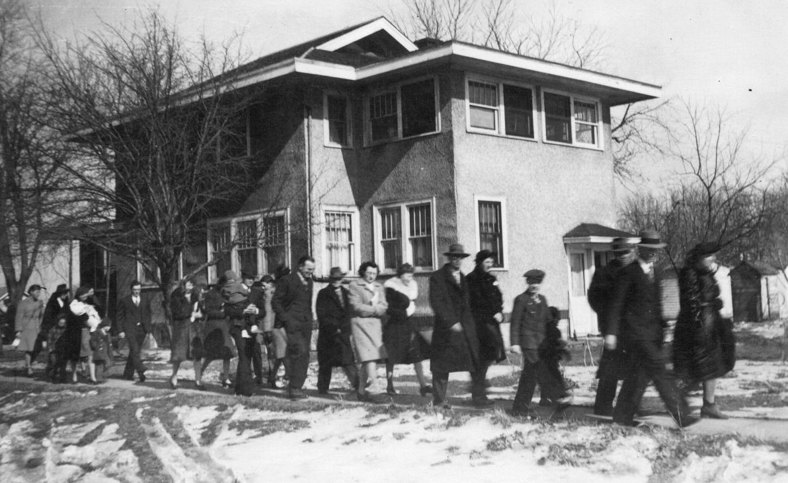
In December, 1943 the Rev. H.J. Knoploh was issued a call which he accepted. He was installed on January 30, 1944 and became the first resident pastor of St. John’s church. The parsonage was formally dedicated a few weeks after Pastor Knoploh’s installation. At this time the congregation applied to the Minnesota District for financial help. The District promised $150 each year for 10 years. But because of changes in the District structure at that time it gave a lump sum payment of $1500. Since that time the congregation of St. John’s has taken care of its obligations independently and has also given support to the general work of the church both at home and abroad.
Dedication of Parsonage

Pastor Knoploh served the congregation until 1948. Following his resignation, a call was extended to the Rev. Hugo Beyer who accepted the call and remained with the congregation until 1951. Pastor Beyer is remembered for his friendliness and many "handshakes." After Rev. Beyer’s resignation in 1951, the Rev. E. R. Sommerfeld was extended a call. He accepted and served at St. John’s until 1958.

It was during Pastor Sommerfeld’s ministry in 1953 that the congregation observed its Ruby Anniversary. Again, extensive improvements occurred prior to the celebration. The parsonage received new shingles, a new water system, a Nu-Wood ceiling in the sun porch, fresh paint, and a garage was built. A new oil burning furnace was installed at the church, two new cloakrooms were added to the church entry, and 2 restrooms were added in the church basement. A long sidewalk lining three sides of the church grounds was poured.

The 40th anniversary celebration was held on Sunday, October 11, 1953. The guest speakers were both former pastors, The Rev. H. J. Knoplok, St. John’s first resident pastor, spoke at the morning service and the Rev. John Mohr spoke at the evening services.

Pastor Sommerfeld’s ministry in Woden ended in 1958 when after a year-long leave of absence he found it necessary to retire for health reasons. During Pastor Sommerfeld’s leave, the Rev. Herman Lechner of Mason City served St. John’s faithfully. He also served as interim pastor following the close of Rev. Sommerfeld’s ministry. During the summer of 1958, a call was extended to the Rev. John H. Jacklin who accepted. He was installed September 7, 1958.

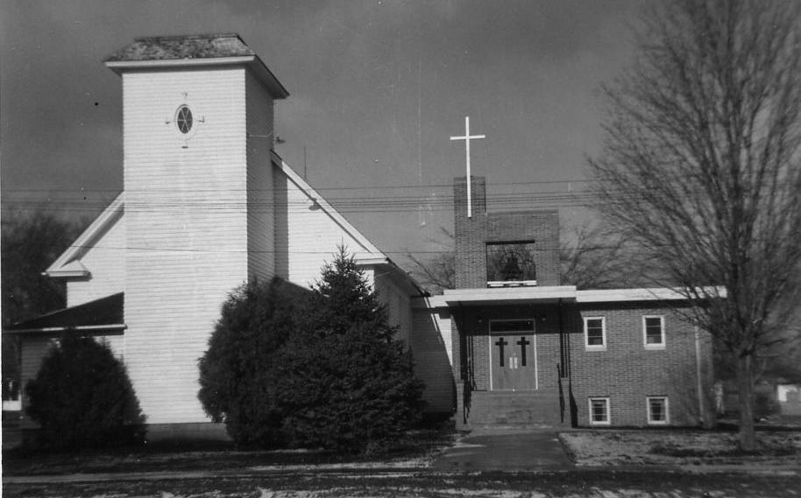
In 1959, the congregation undertook a large project, namely that of building a parish hall addition. The need for it was very acute…a crowded narthex, insufficient seating and lack of Sunday school rooms were the chief problems. In addition, the sanctuary was completely remodeled and redecorated. The women of the church raised the money to finance the laying of new tile flooring in the church and the oil burning furnace which had been in the church was moved to the parsonage.
Parish hall addition

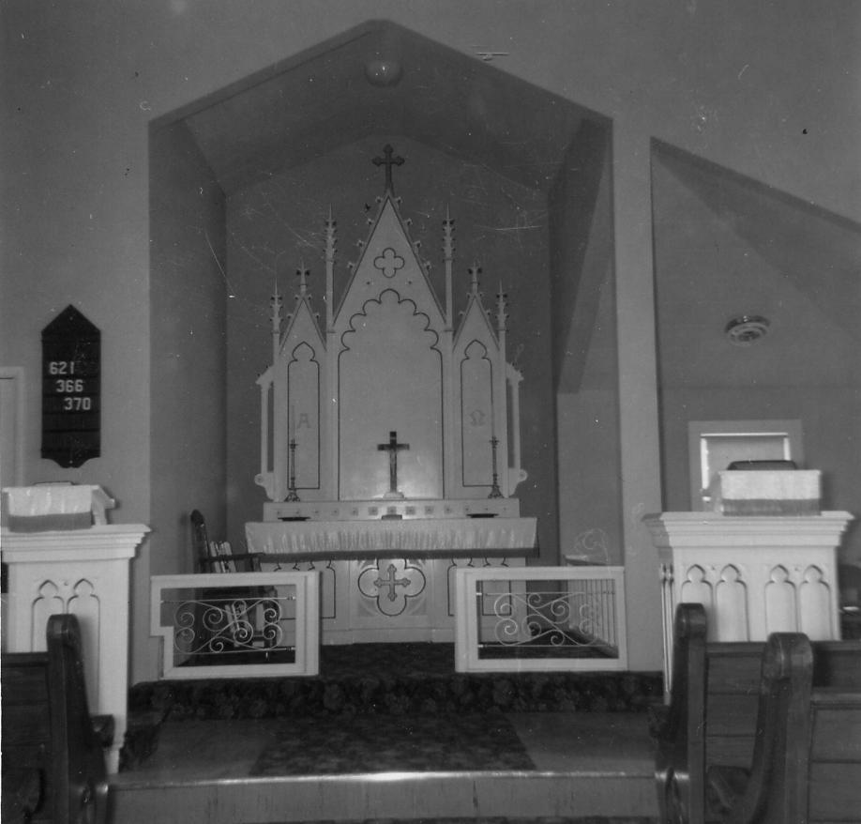
On December 6, 1959 the parish hall and remodeled church were dedicated. Dr. H.H. Siefkes, president of the Iowa District of the American Lutheran Church delivered the sermon and performed the rite of dedication assisted by Pastor Jacklin. At the afternoon service, greetings were brought to the congregation by neighboring pastors. The Senior Choir and a men’s quartet provided special music. There was also an evening service where greetings were read from former pastors and Rev. Jacklin spoke briefly. The women of the congregation prepared a noon meal and an evening fellowship meal. The offering at these services amounted to over $1600 which was given to debt retirement. The total cost of the parish hall and remodeling of the church was over $40,000. Just a few years later the debt was paid in full and celebrated with a mortgage burning ceremony on Sunday, November 13, 1966.

In the years between 1959 and 1963 improvements continued to be made by the congregation and various organizations in the church both to the church building and to the parsonage. The women of the church purchased new curtains, new carpeting in the nave of the church and a new piano. The Lutheran Brotherhood provided new blackboards for the Sunday school rooms, blacktop for the parking area, a partial bathroom and new front steps for the parsonage. In addition, new equipment and the new Service Book and Hymnal were purchased at this time.
Remodeled sanctuary

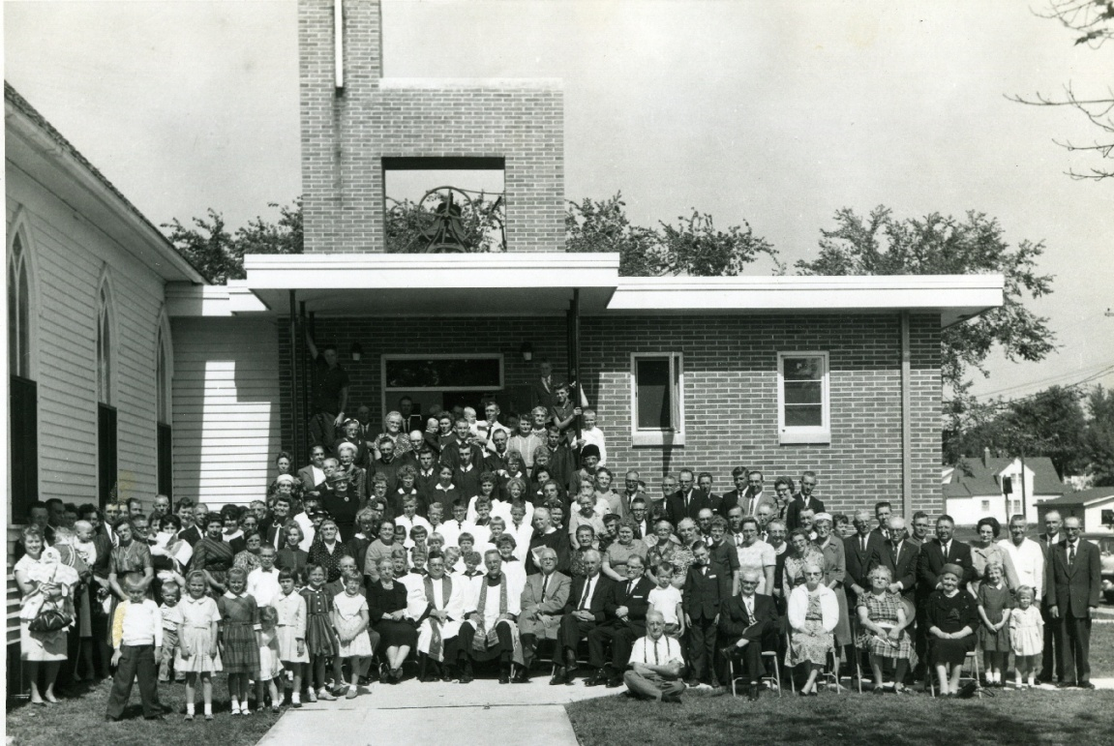
St. John’s celebrated another historical milestone on September 15, 1963 when the 50th anniversary of the church was honored. The Rev. I.B. Sorenson, administrative assistant to the District president delivered the sermon that morning. Both the Junior and Senior choirs sang at the service. A display of photographs relative to the congregation’s history was displayed in the social hall. A congregational picture was taken to commemorate the event.
St. John’s Congregation - 1963

Also in 1963, the congregation and the world mourned the death of President John F. Kennedy. St. John’s held a memorial service honoring the slain president.

During the summer of 1969, Pastor Jacklin resigned and moved to a parish in LaPorte City. A letter of call was extended to the Rev. Luther M. Flugstad, a former missionary from the Sudan, West Africa, who had just resigned and was moving back to the states. He accepted the call and was installed on September 28, 1969 by the Rev. Alvon Nelson, executive assistant of the Iowa District.
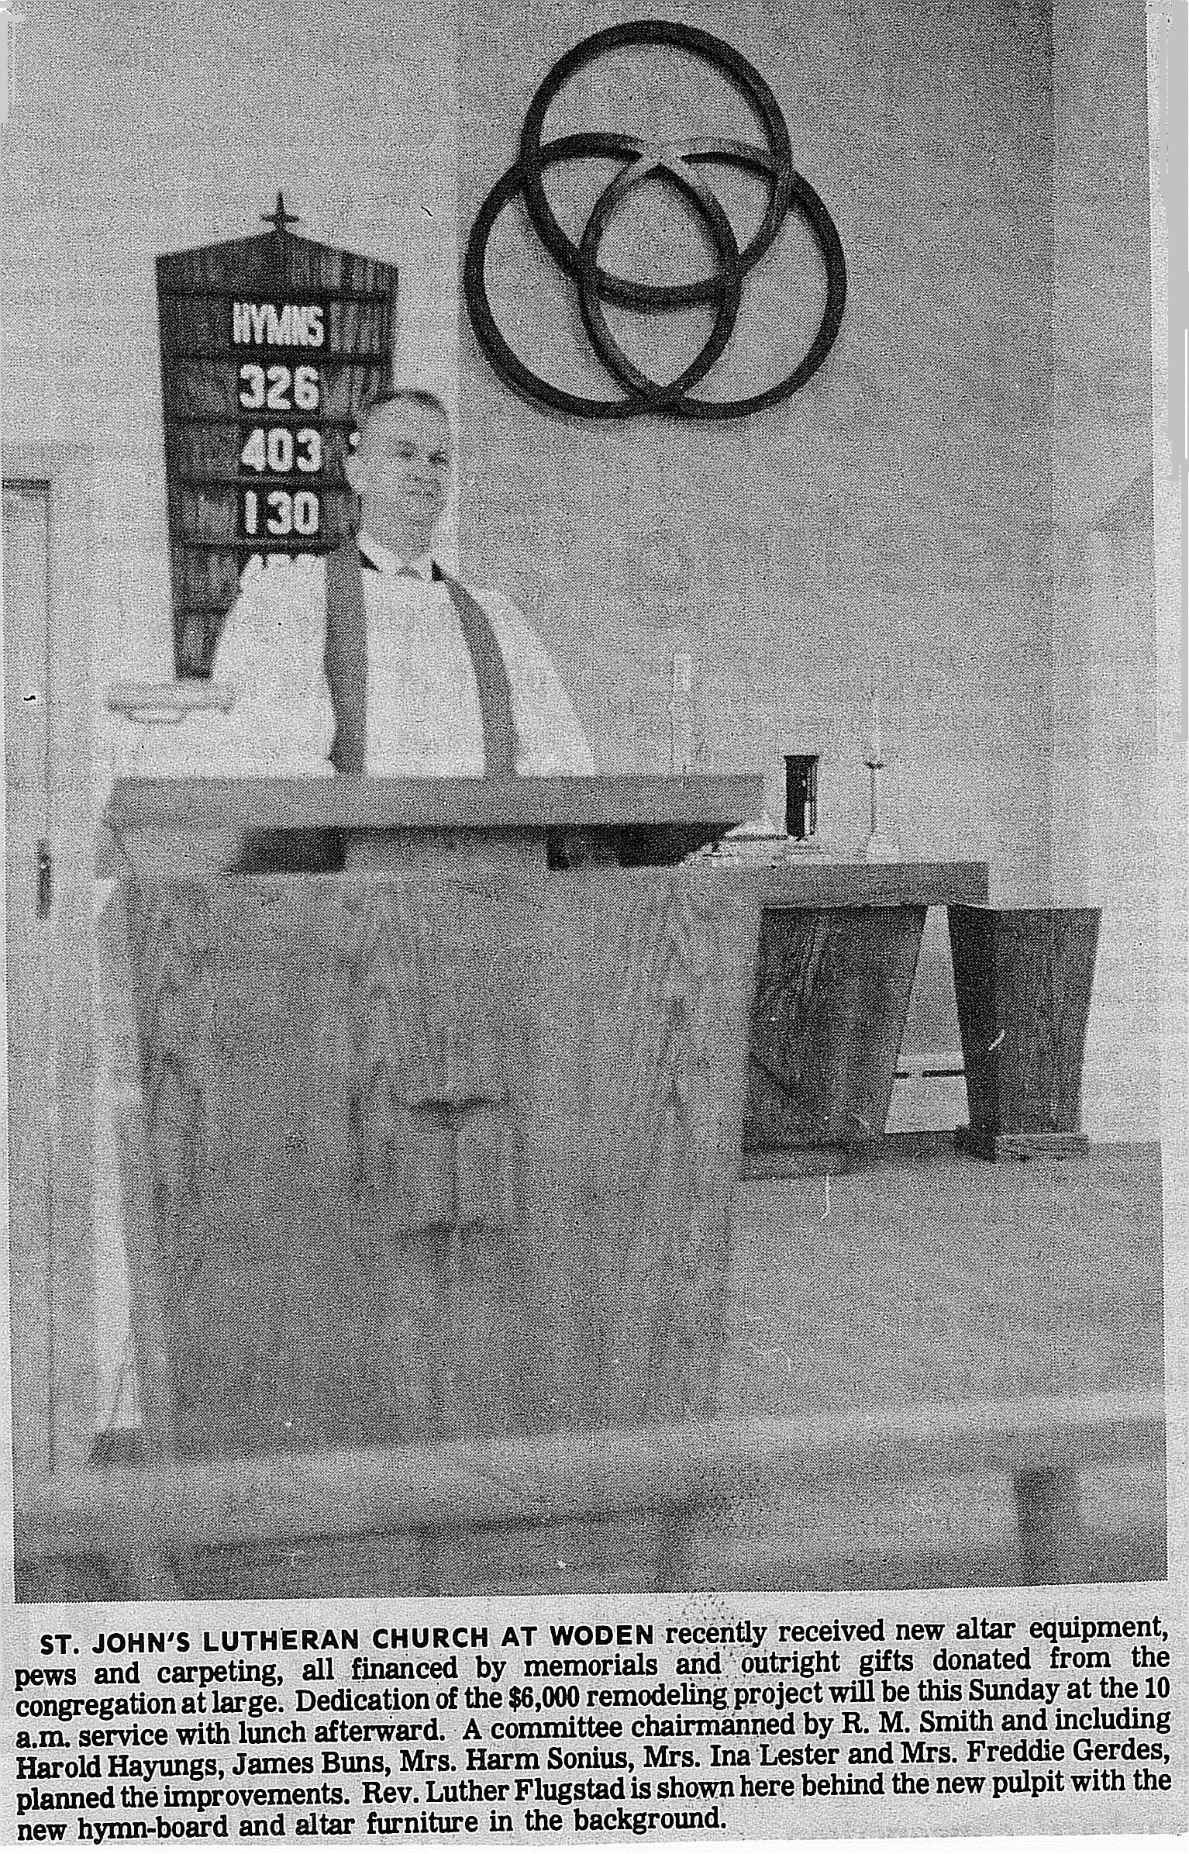
From 1969 – 1971, a number of improvements and additions were made to the church and parsonage. Memorial gifts made much of the improvements possible. New church furniture was purchased. The altar was given in memory of Fred and Rebecca Gerdes, Sr., by Fred, Herman and Hilda Gerdes. The pulpit was given in memory of Hannah and August Brunsen by the Brunsen family. The lectern was given in memory of Herbert and Anna Doege by their children. The trinity symbol was presented by Mr. and Mrs. Carl Marker and their three children, Arnold, Janet and Douglas. The baptismal font was given in memory of Mr. Fritz. T. Gerdes by Mrs. Gerdes and family. Gifts given in memory of Mr. Martin Smith by Mrs. Smith and friends were also noted. Other memorial gifts given were recorded in a memorial book placed in the narthex of the church. The Brotherhood built and erected a church sign. The Luther League built an outdoor bulletin board. All of those items plus the church pews were dedicated to God’s glory and for use by the congregation on Sunday, September 5, 1971.

During this time a Board of Parish Education was established to assist in meeting the educational needs of the congregation at St. John’s. Various groups within the church were active in fund raising and nurturing the members of the congregation and community both locally and worldwide.

St. John’s celebrated its 60th anniversary in 1973. As was the tradition, plans were made to make improvements to the church building. In January, 1973 the congregation voted to remodel the “old church basement” as it was often called. The space was divided into two classrooms, a storeroom, a mimeograph room, and a carpeted pastor’s study was created which was readily accessible to both the outside and the sacristy. The arrangement of the large space added greatly to the facility. By September, St. John’s was ready for their anniversary celebration. On September 30, 1973 former members, relatives and friends joined the congregation to renew old acquaintances and make new friends. The Rev. John Jacklin preached the sermon. Many musical numbers were presented. A congregational picture was taken in memory of the occasion. Many old pictures, slides and other remembrances of the past were also displayed. The women of the church served refreshments.

Pastor Flugstad resigned in 1974 and St. John’s was served by an interim pastor from Forest City, Pastor P. L. Mork, from September 1974 – June 1975. In 1975, a call was issued to the Rev. Curt M. Joseph and was accepted. Pastor Joseph, his wife Lisa and daughter Tanya came to Woden and he was installed on June 15, 1975. Pastor Joseph was a graduate of Wartburg Seminary and St. John’s was his first parish. Church membership and attendance continued to grow during that time. Communion services were set to be held the first Sunday of every month. On July, 27, 1976, Leah Elizabeth Joseph became the first baby to be born to a resident pastor.

In 1977, St. John’s entered into a cooperative ministry venture with surrounding Lutheran churches. This cooperative ministry proved beneficial to many. A Sunday School Teacher seminar and a Luther League Officer’s retreat were just two of the ventures the group sponsored. The highlight of the cooperative ministry effort was an Evangelism event that was held in the fall. Pastor Al Hermier from Northwood preached on Sunday morning, Sunday evening, Monday evening, and Tuesday evening. A joint communion service was held on Sunday as well.

