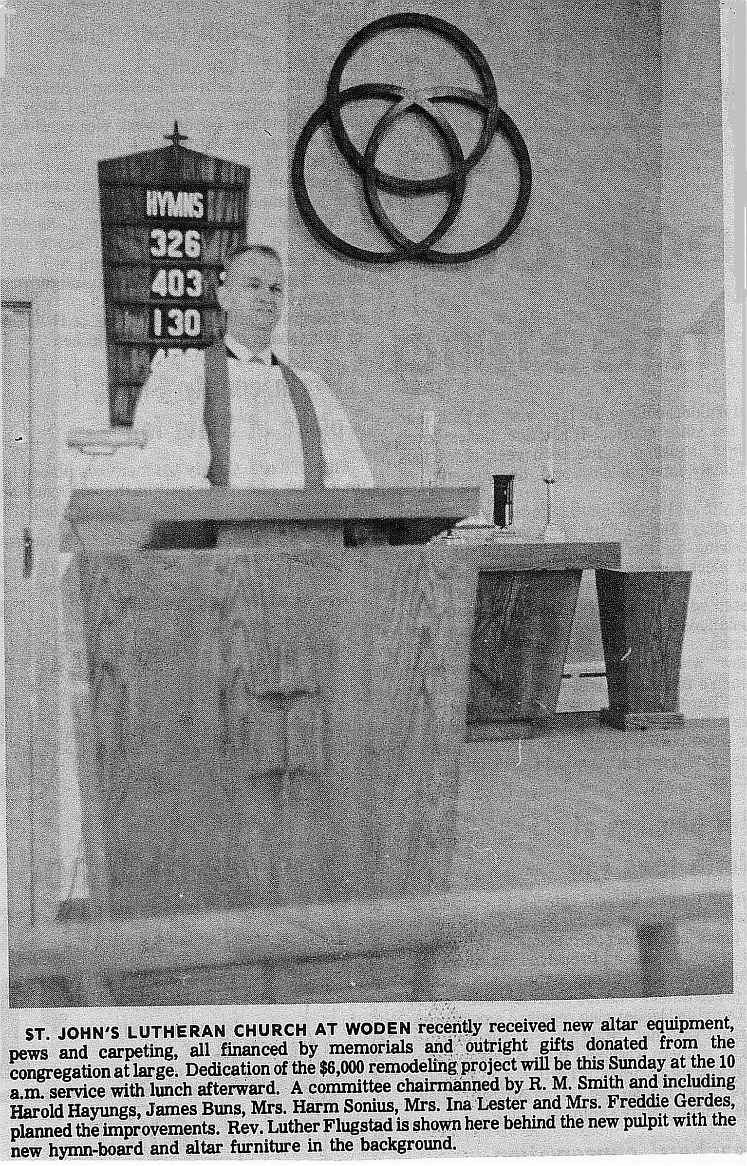
From 1969 – 1971, a number of improvements and additions were made to the church and parsonage. Memorial gifts made much of the improvements possible. New church furniture was purchased. The altar was given in memory of Fred and Rebecca Gerdes, Sr., by Fred, Herman and Hilda Gerdes. The pulpit was given in memory of Hannah and August Brunsen by the Brunsen family. The lectern was given in memory of Herbert and Anna Doege by their children. The trinity symbol was presented by Mr. and Mrs. Carl Marker and their three children, Arnold, Janet and Douglas. The baptismal font was given in memory of Mr. Fritz. T. Gerdes by Mrs. Gerdes and family. Gifts given in memory of Mr. Martin Smith by Mrs. Smith and friends were also noted. Other memorial gifts given were recorded in a memorial book placed in the narthex of the church. The Brotherhood built and erected a church sign. The Luther League built an outdoor bulletin board. All of those items plus the church pews were dedicated to God’s glory and for use by the congregation on Sunday, September 5, 1971.

During this time a Board of Parish Education was established to assist in meeting the educational needs of the congregation at St. John’s. Various groups within the church were active in fund raising and nurturing the members of the congregation and community both locally and worldwide.

St. John’s celebrated its 60th anniversary in 1973. As was the tradition, plans were made to make improvements to the church building. In January, 1973 the congregation voted to remodel the “old church basement” as it was often called. The space was divided into two classrooms, a storeroom, a mimeograph room, and a carpeted pastor’s study was created which was readily accessible to both the outside and the sacristy. The arrangement of the large space added greatly to the facility. By September, St. John’s was ready for their anniversary celebration. On September 30, 1973 former members, relatives and friends joined the congregation to renew old acquaintances and make new friends. The Rev. John Jacklin preached the sermon. Many musical numbers were presented. A congregational picture was taken in memory of the occasion. Many old pictures, slides and other remembrances of the past were also displayed. The women of the church served refreshments.

Pastor Flugstad resigned in 1974 and St. John’s was served by an interim pastor from Forest City, Pastor P. L. Mork, from September 1974 – June 1975. In 1975, a call was issued to the Rev. Curt M. Joseph and was accepted. Pastor Joseph, his wife Lisa and daughter Tanya came to Woden and he was installed on June 15, 1975. Pastor Joseph was a graduate of Wartburg Seminary and St. John’s was his first parish. Church membership and attendance continued to grow during that time. Communion services were set to be held the first Sunday of every month. On July, 27, 1976, Leah Elizabeth Joseph became the first baby to be born to a resident pastor.

In 1977, St. John’s entered into a cooperative ministry venture with surrounding Lutheran churches. This cooperative ministry proved beneficial to many. A Sunday School Teacher seminar and a Luther League Officer’s retreat were just two of the ventures the group sponsored. The highlight of the cooperative ministry effort was an Evangelism event that was held in the fall. Pastor Al Hermier from Northwood preached on Sunday morning, Sunday evening, Monday evening, and Tuesday evening. A joint communion service was held on Sunday as well.

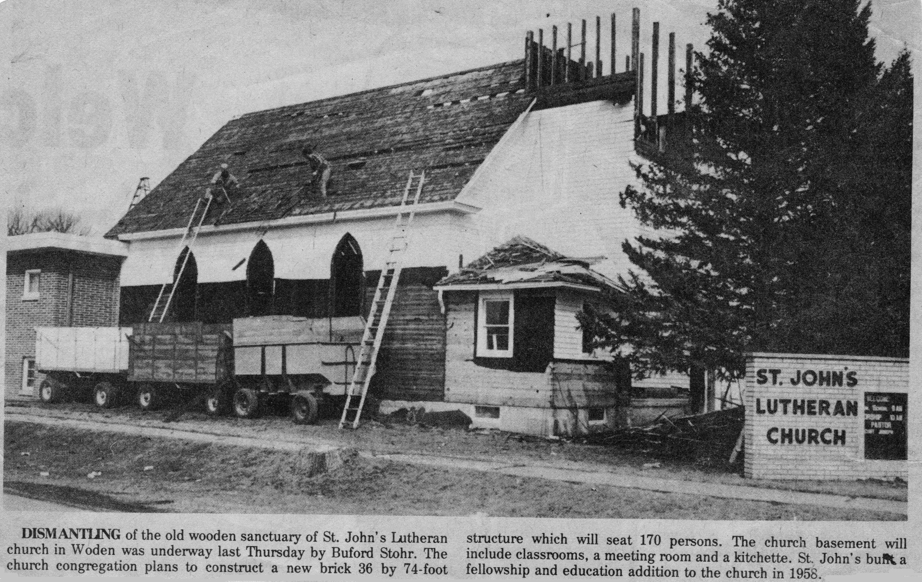
In January, 1977 discussion began about whether to build a new church or remodel the old one. A building committee was established to explore the feasibility of undertaking the project. Estimates to build a new church were set at around $125,000. In the giving, supportive tradition of St. John’s, members of the congregation pledged $50,000 for the first year and another $40,000 was pledged over the next three years. Many members said they would help with donated time and labor. On July 4, 1977 the congregation of St. John’s voted to build a new church beginning in 1978. Ground breaking was scheduled for May with construction to be completed by late October.

.
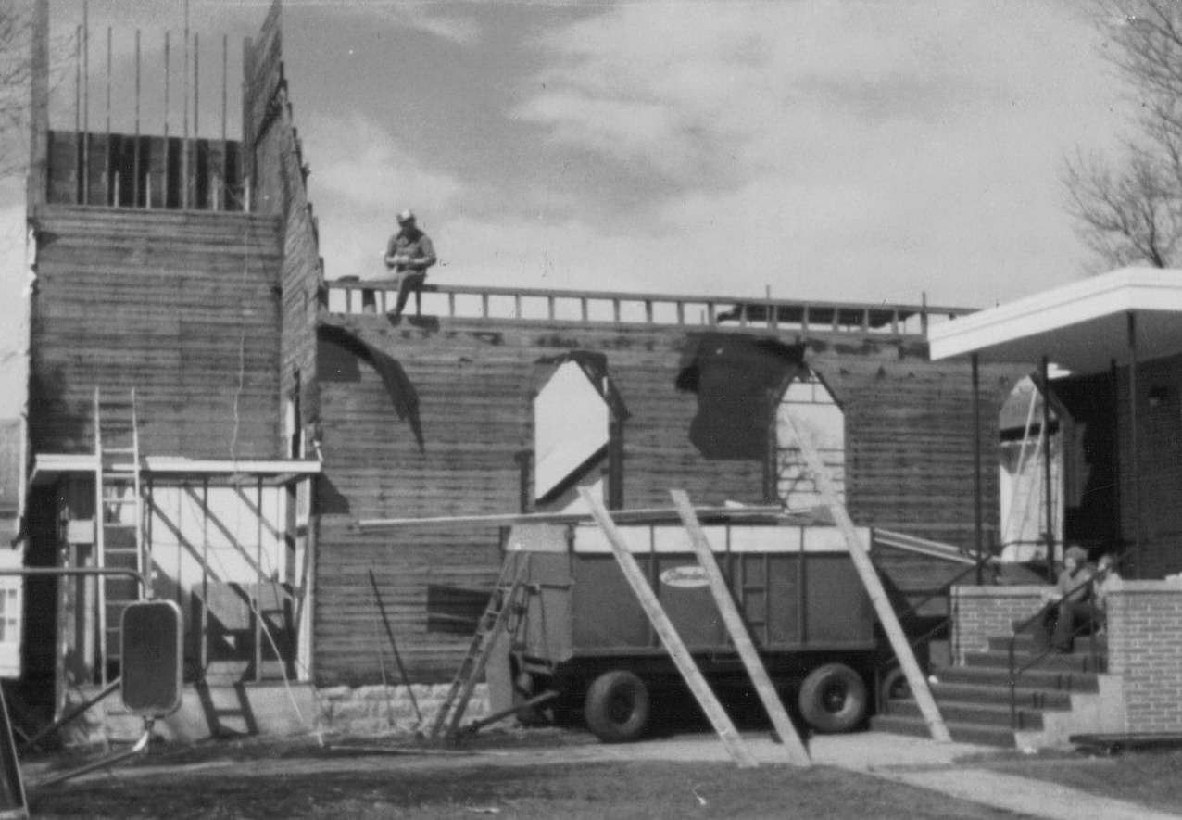
Demolition began on the old church in March 1978. By May 1, 1978 the old church had been torn down and the digging began
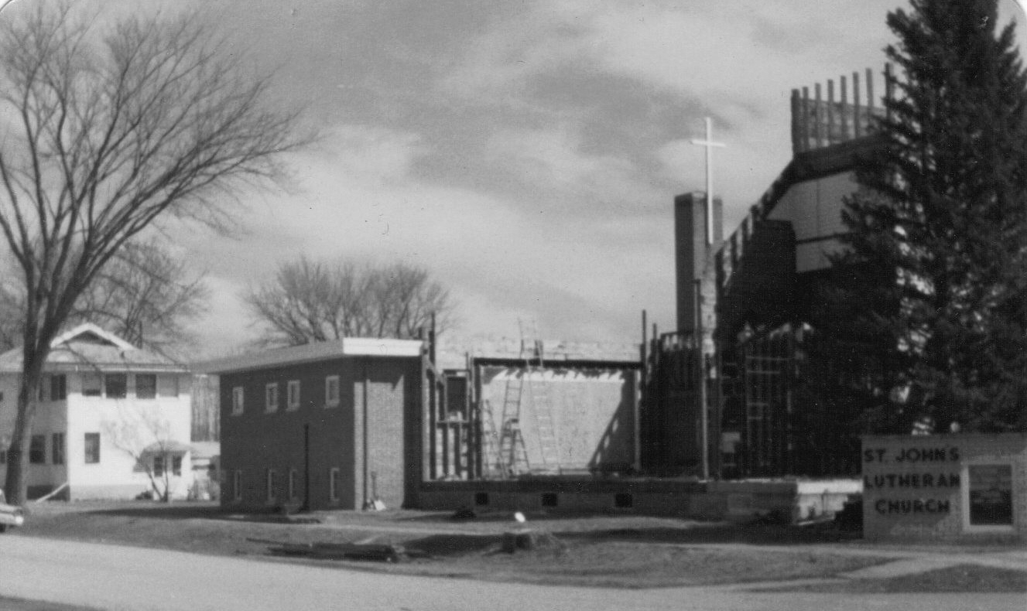

The building committee worked on the outside design and the Gunder Church Company was consulted regarding the interior design.
Construction began on the newly designed church in late spring and the congregation watched as their dream for a new church building was realized.

