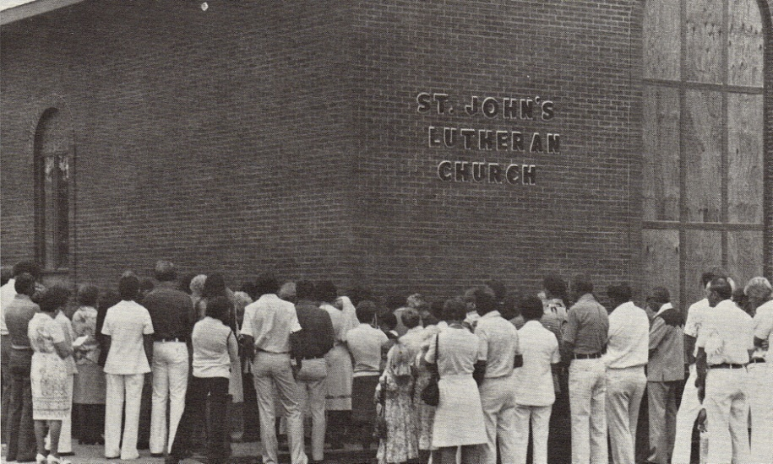
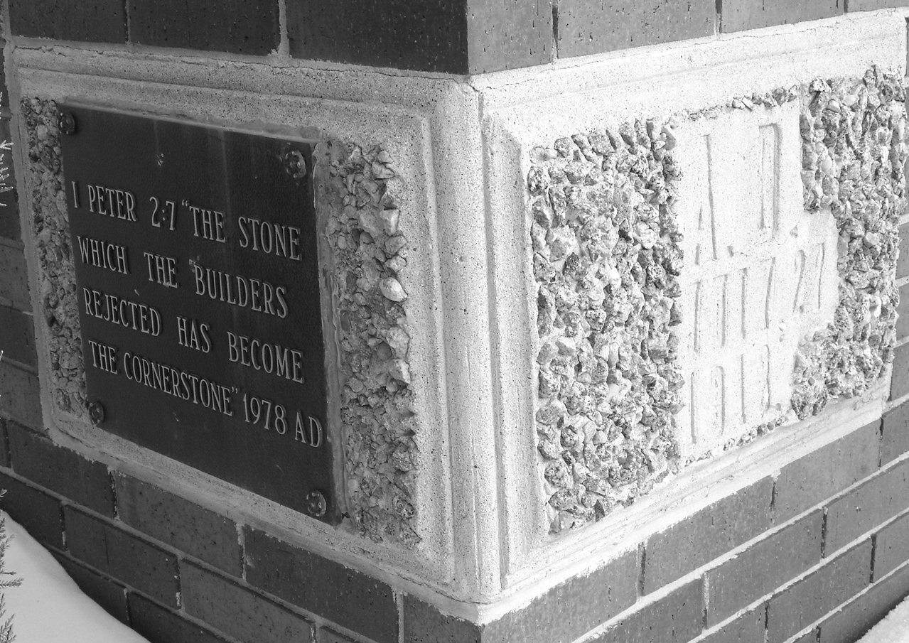
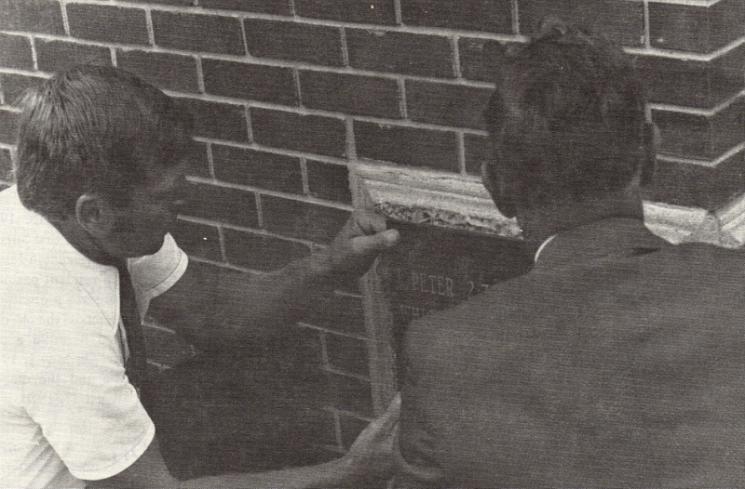
Congregation celebrates the laying of the cornerstone - August 27, 1978.

When the church building was completed, Pastor Curt Joseph thanked God for His Blessings and encouraged the congregation to look outside of the church building to identify the needs of the community and the world.

Pastor Joseph wrote, “I believe we were put here not to stay within the confines of this beautiful structure, but to use this building for the glory of God. This is not a fortress against the evils of the world, but it is a place where we can go out from to bring the Gospel to our fellow man.”
The cornerstone of the new building was laid on August 27, 1978.
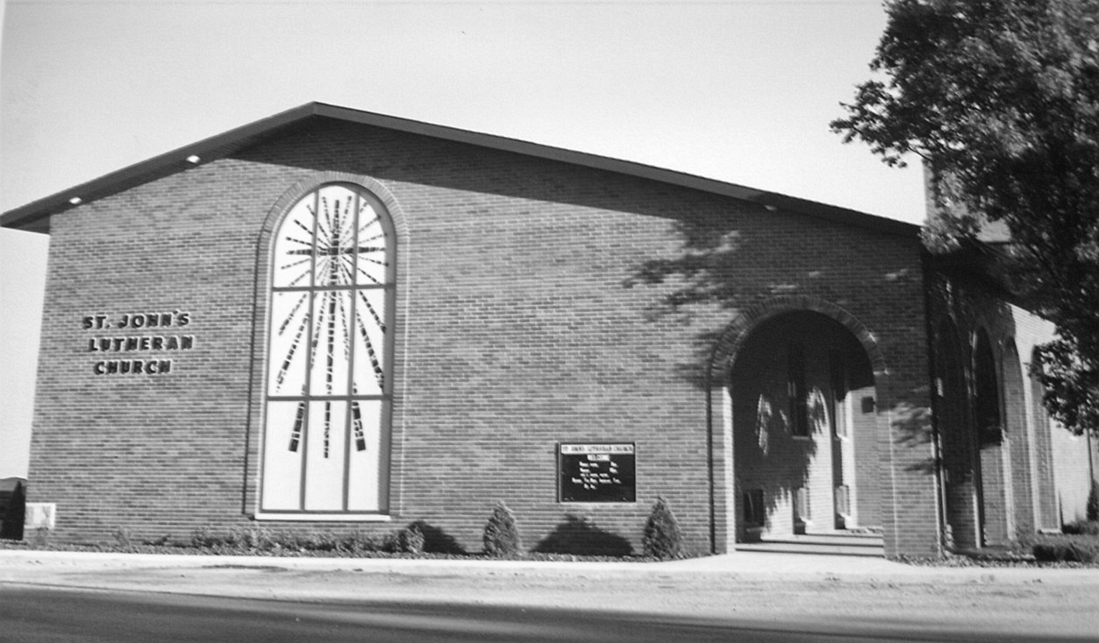

A ceremony dedicating the new church building was held on December 10, 1978. St. John’s Lutheran Church was dedicated to the glory of God, by whom the church was built, to honor Jesus Christ and praise the Holy Spirit. The church was dedicated for the preaching and teaching of the Word, the proper administration of the Holy Sacraments of Baptism and Communion, and as a house of prayer.
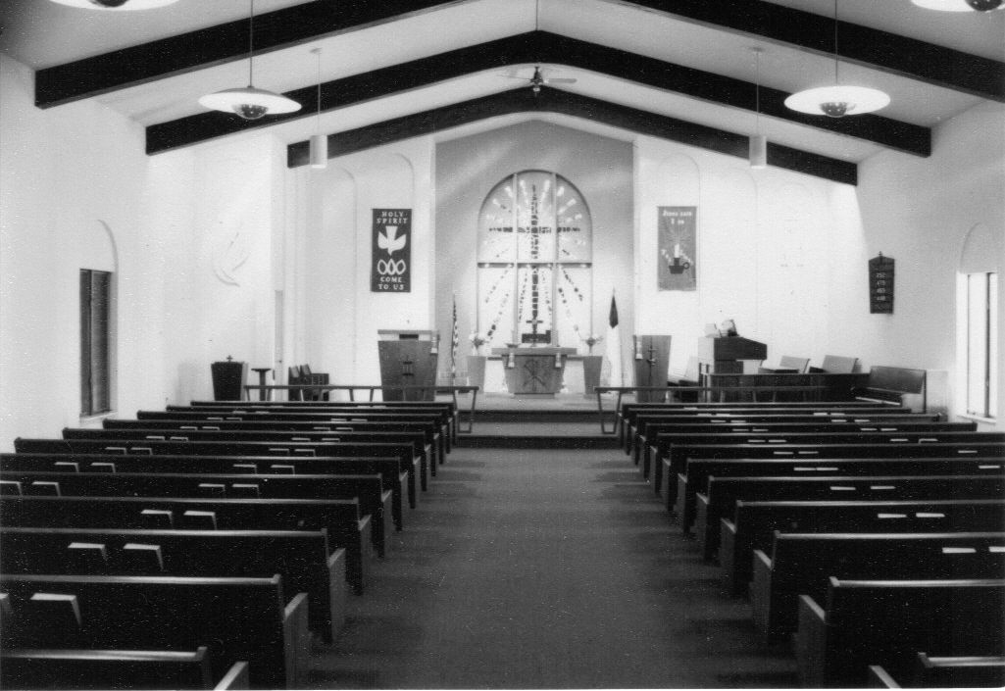

The church was dedicated for the comfort of those who mourn, for strength to those who are weak, for help to those who are tempted, and as a place where little children may increase in wisdom and favor with God and man. St John’s was dedicated for the fellowship of believers and for the work of the Lord at home and abroad. Finally, it was dedicated as a tribute of gratitude and an expression of faith and hope as a place in which God might manifest His presence to man, where sinners may receive comfort and assurance, where men may be turned to repentance and faith, where saints may be strengthened and encouraged, where God’s praise will be declared, His kingdom extended, His glory revealed and His power manifested.

Sanctuary of the new church
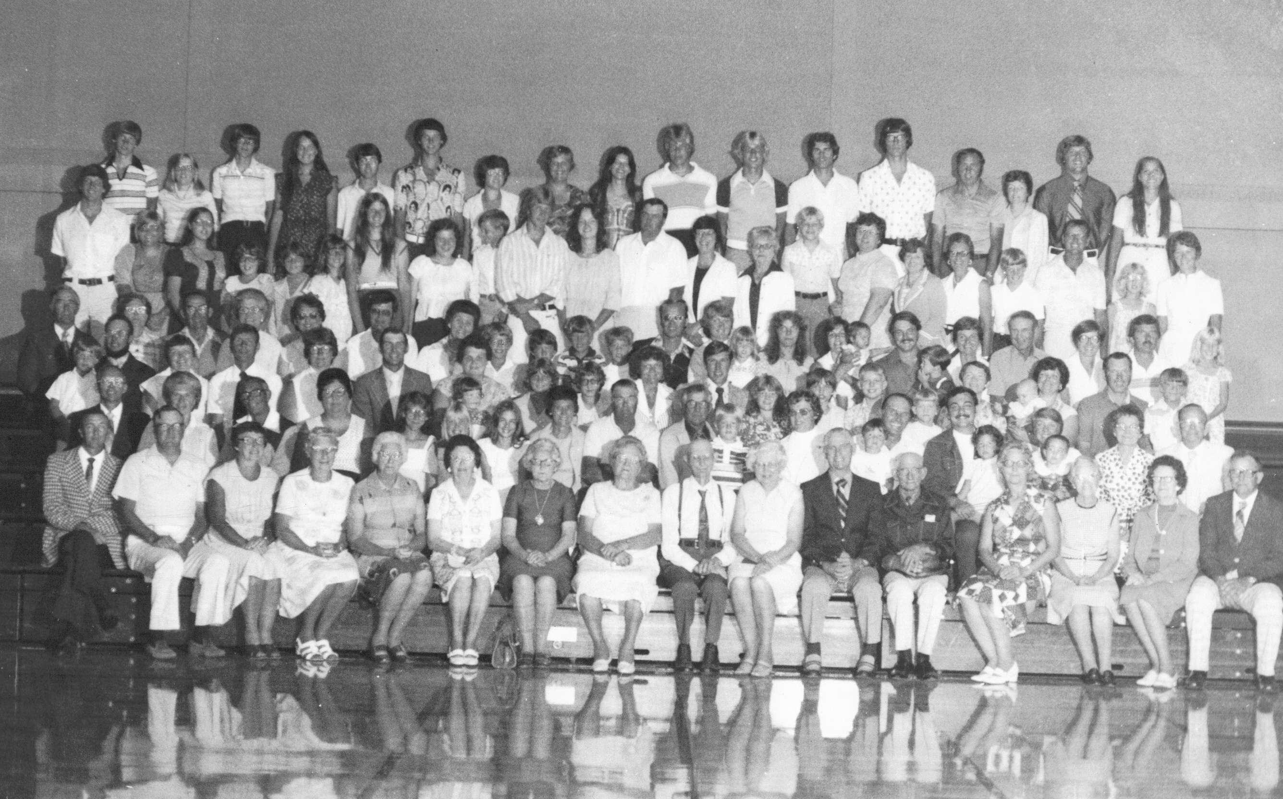
Congregation of St John’s Lutheran Church - 1978

Dr. Durwood Buchheim, President, Iowa District The American Lutheran Church, inspired the congregation with his message at the morning dedication celebration and Rev. William Granger, the Dean of the Mason City Conference, spoke at the afternoon service. The Rev. David Vigen and a former pastor of St. John’s, the Rev. John Jacklin, also shared messages at the afternoon service. The congregation enjoyed special music, food and fellowship that day and gathered for a special photograph to commemorate the event.

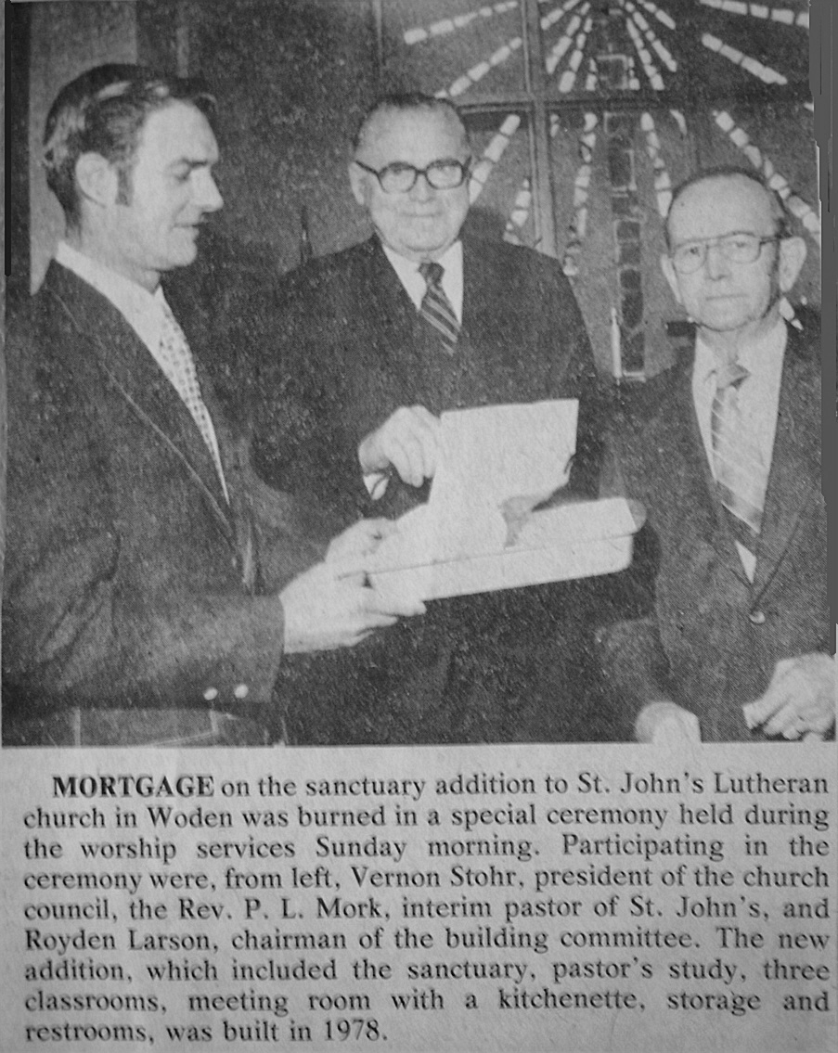
St. John’s said goodbye to Pastor Joseph in September, 1981 when he resigned. A dinner and a short program were held in honor of Pastor Joseph and his wife and children. Gifts were presented to them in appreciation of their ministry. Following Pastor Joseph’s departure, St. John’s welcomed Pastor P. L. Mork back as interim pastor from September 1981-March 1982. Pastor Mork had previously served St. John’s as interim pastor prior to Pastor Joseph being called.

The 1980’s were difficult times in the history of our country and some of those difficulties were felt in our local communities and church families as well. While St John’s celebrated the retirement of the church’s debt at the end of 1981 with a mortgage burning ceremony in early 1982, many found it more and more difficult to support the church financially. The farm crisis affected many people throughout the nation and its effects were felt close to home as well. However, in the tradition of our founding fathers, the members of St. John’s sustained and nurtured our church home, as well as each other, through those difficult times.

In 1982 a call was issued to Pastor Mark W. Smith who came to Woden in March of that year. His installation service was held on March 21, 1982. This year also celebrated a revival of Junior Lutherans. This group met on a regular basis and enjoyed fellowship with one another. During this time the Luther League was strong and committed as well and in 1985 joined with Grant and Calvary Lutheran churches in accomplishing the mission of the group.

In spite of difficult financial times, improvements to the church and parsonage continued throughout the 80’s. In 1983 new flooring was laid in the fellowship hall, a much needed improvement. A new resource room was underway and nearly completed. This room was anticipated to be a useful and integral part of the congregation’s life. A dedication of the room was held in April, 1984. In 1988 the congregation explored the possibility of purchasing an improved sound system at a cost of $1000-$1400. They also voted to raise funds to air condition the worship area and fellowship hall which was installed in the church in 1989 at a cost of approximately $10,000. In the tradition of our forefathers, it was paid for by the time it was installed. Other projects during the 80’s included remodeling the basement, a piano for the parish hall, and ongoing upkeep and improvements throughout the church and the parsonage.

As in the past, our congregation in the 1980’s recognized that there were many within our midst that were struggling in one way or another and in need of extra assistance. In an effort to meet the needs of the people of God, a Perpetual Need Fund (PNF) was established in 1986. The purpose of this fund was to identify and meet needs as they arose. A committee was formed to determine how the fund would be set up, including the amount of the fund, how it would be used, who the committee would consist of, how often the committee would meet, who could qualify for funds, and to identify what the needs were. In 1988, a plaque recognizing donors to the PNF was secured and placed in the narthex of the church.

Pastor Mark Smith announced to the congregation his intention to resign on June 23, 1985. Shortly after his departure the congregation began the process of preparing for a new pastor. Pastor Norbert Jolivette confirmed the class of 1986. Early in 1986, a call was issued to Pastor Keith Klemm which he accepted. He began his ministry at St. John’s in June 1986.

As the 1980’s continued, the church began to experience change once again. In January, 1987, a ballot was distributed to members of St. John’s to vote whether the American Lutheran Church (ALC) should join the proposed new Evangelical Lutheran Church of America (ELCA). The proposed unification had been approved by the Church Council of the ALC and the General Convention of the ALC. Each ALC member congregation was allowed to cast one vote to approve or disapprove the proposed unification. A favorable vote of at least 2/3 of the congregations casting ballots was required for ratification. On January 1, 1988 St John’s Lutheran Church became a member of the ELCA. We were already “evangelical” according to our congregation’s church seal which identified us as “St. John Evangelical Lutheran Church, Woden, Iowa.” Following the change, the women’s group of the church was restructured and the Luther League was organized on conference level. St. John’s also began to look at revising the congregational constitution. On Ash Wednesday in 1988, the women of the congregation prepared and served a soup supper to celebrate the 80th anniversary of church charter. Bishop Miller helped celebrate.

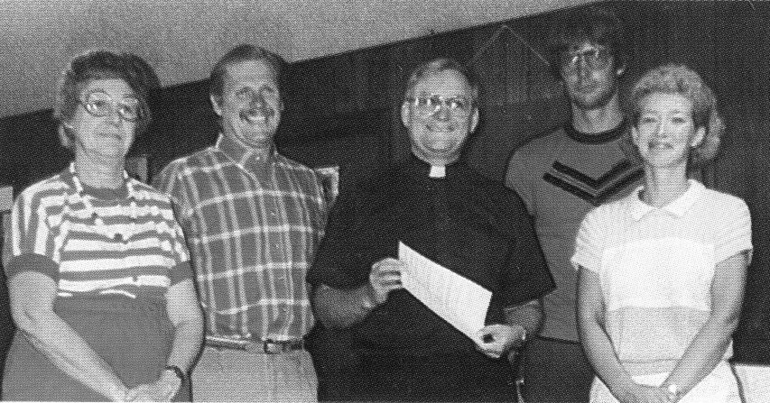
As the 1980’s came to a close, it was more and more apparent that many rural congregations were experiencing a decline in growth and active membership. As the demographics of our nation continued to change, St John’s and other churches were forced to look at opportunities to partner and share their resources with each other. Discussion took place regarding a “yoking” or shared ministry with Grant Lutheran Church of rural Woden. The council voted to pass the shared ministry agreement with Grant and presented the vote to the congregation, who voted with an overwhelming majority in favor of the agreement. On August 1, 1989 St. John’s partnership with Grant began and the 1980’s rolled to a close.
Signing the shared ministry agreement

Like each decade before it, the 90’s were a time of change, of blessings and loss, of growth and decline, of new and old. Hoping to encourage growth and an increase in active membership, a committee of lay volunteers attempted to make a visit to every member of St. John’s in 1991-1992. People were asked to comment about the strengths of St. John’s, pastoral calls and any special concerns that they might have. Responses from the members were positive.

Improvements to the church and parsonage during the 90’s were many and included a phone line in the pastor’s office with an answering machine, new plumbing, a water softener, and a new water heater at the parsonage, and new paint for the church and parsonage. Repair of the parish hall roof at a cost of $10,000 was completed in November of 1992. St. John’s put in a new chair lift, repaired the roof of the church, installed smaller spotlights in the sanctuary and the ladies of the church bought a new vacuum cleaner. As always there was painting and cleaning that took place and the parsonage got new carpeting and linoleum, as well as a new kitchen island. The parking area received a coat of blacktop and the sign along the highway got a face lift. Late in the 90’s discussion began regarding new carpeting and furniture for the fireside room, Sunday school rooms, and hallways in the basement. The possibility of installing a new furnace was also explored.

1993 was the year of the Iowa flood. St. John’s participated in many fund raising and humanitarian efforts to assist those most affected by the disaster. In a year when so many were struggling and without extra to give, St. John’s received an anonymous gift of $5000. A note from the bank to Pastor Klemm read, “One of God’s servants asked me to send this gift to your church anonymously. Your efforts for the Lord are appreciated.”

St. John’s continued to reach out to members of the church as well as the community and hosted several activities open to all including a marriage enrichment event, parenting classes, and a discussion of divorce. In July, 1995 St. John’s hosted a video presentation of “Hollywood versus Religion.” The video explored Hollywood’s portrayal of people of faith in negative ways and opened a forum for discussion of how we could turn this negative perception into a positive one.

During this decade there was a review and revision of the constitution to make it more in keeping with the model constitution of the ELCA and the church council and the board of education were reorganized. St. John’s and Grant began to show interest in meeting with Good Hope and Immanuel Lutheran Churches to explore the possibility of cooperative ventures such as joint worship services and activities. The LYO’s of these churches began to work together during that time. In 1996, Pastor Klemm announced the establishment of three new ministries within St. John’s: Pastoral visits on all members to check on their spiritual health and to share scripture and prayer; a prayer chain was established; Saturday evening worship would be conducted during the summer months. During this year, St. John’s began to use the new “With One Voice” Hymnals and dedicated them during a ceremony on October 13th.

Tragically, in June of 1997 Pastor Keith Klemm was killed in a car accident near Woden. His sudden loss was devastating to his family, the community, and members of St. John’s and Grant. A funeral service was held to celebrate Pastor Klemm’s life and the church overflowed with people who loved him and would miss his presence here on earth. Pastor’s wife Kathy remained at the parsonage until the end of July.

On June 18th a special council meeting was held with Bishop Miller to determine a course of action for St. John’s and to begin the process of healing. The council met with Pastor Keith Seivers and voted to extend a call to him to serve as interim pastor at St. John’s and Grant. His family remained in Ft. Dodge but he occupied the parsonage at times. Pastor Sievers attended the July council meeting and voiced that his goal was to lead the members of St. John’s and Grant to “healthful and hopeful conclusion of the 11-year ministry shared with Pastor Klemm.” To grieve and say goodbye to a dear friend and beloved pastor is crucial work to do and Pastor Sievers led the congregations in that grieving process.

In October of 1997, the Waldorf conference sent a $100 memorial gift in memory of Pastor Klemm and new oil burning altar candles were dedicated in his memory. Then it was time to move ahead and to prepare for the next pastor and a call committee was established. Their work began with a self study. Pastor Sievers assisted the committee and the congregation to identify our priorities as a church, identify the church’s ministry, to establish goals and to begin to work toward them.

On June 14, 1998, St John’s and Grant celebrated Pastor Sievers 20th anniversary in the ministry with a joint service, special music and fellowship after the service. Pastor Sievers accepted a call to serve Kanawha’s congregation and left at the end of July. Pastor Klaus Raab was called to serve as interim pastor in his absence. By August of 1998, the call committee was in Phase 5 of the call process and had met with Pastor Arlen Lloyd from Gatzke, MN. The council recommended that we extend a call to Pastor Lloyd and on September 6, 1998 the congregation voted in agreement. A call was extended and Pastor Lloyd accepted.

Pastor Raab’s last service was on October 25th. A joint service was held at St. John’s and the Junior Lutheran’s served a lunch after the service. Pastor Raab moved to Kimballton and the congregation helped to pay his moving expenses. Pastor Lloyd, his wife Dawn and daughters Kelsey and Kylene moved to Woden on November 5, 1998. Installation was held on November 15, 1998 with a potluck dinner following.

During the last two years of the 1990’s, St. John’s began to work with a new pastor, prepared for Woden’s centennial celebration in 1999 and began to develop a plan for ministry in the 21st century. Grant joined St. John’s Sunday school, the church roof was repaired again, and St. John’s continued to reach out both locally and abroad.
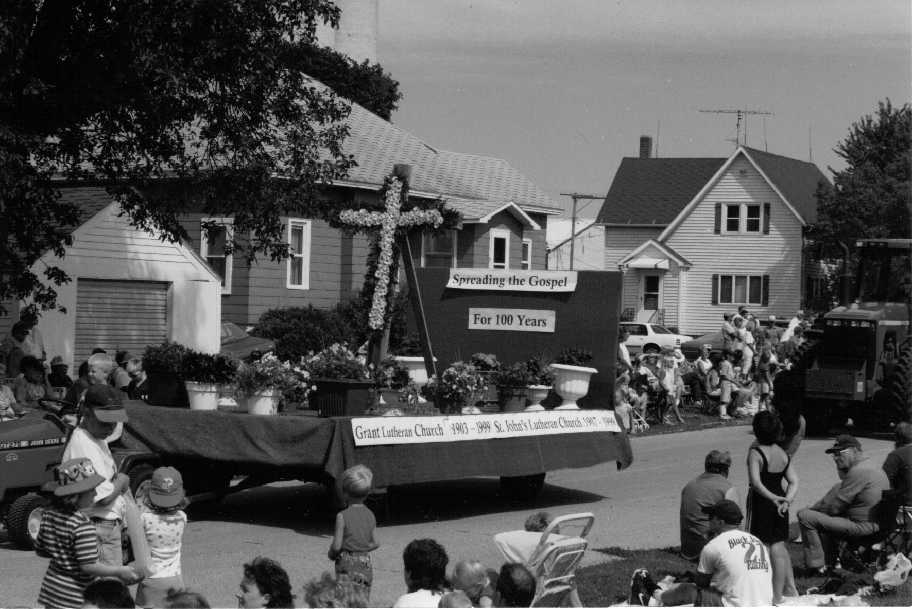

In the summer of 1999, St. John’s helped Woden celebrate its 100th birthday. A float in the centennial parade was just one of the many activities that we participated in that summer.

This was not the first float sponsored by St. John’s in a community parade as the picture below demonstrates.

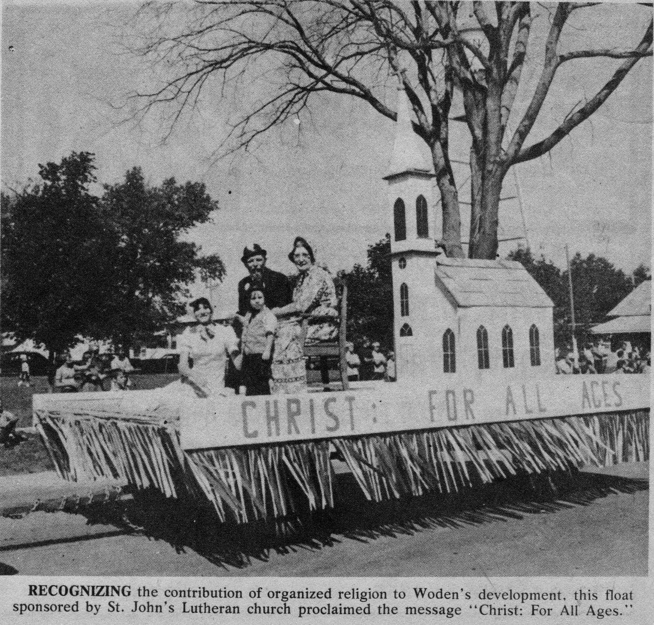

The twenty-first century began a new era in the history of St. John’s. While many traditions continued, new traditions and practices were born. In the first two years of the new millennium, the church underwent some needed repairs. Carpeting was installed in the basement, a new advent wreath and candles were purchased by the women of the church, a new furnace was installed and the church received a new roof.

In August of 2001, more than 25 people came together to shingle and repair the church roof. It was exciting to see both members and non members working together to “get the job done.”

The people of St. John’s continued to reach out in areas of mission during those years and began to explore a “pairing and sharing” relationship with Immanuel Lutheran Church of rural Titonka. A new bishop of the Western Iowa Synod (WIS) was elected, Bishop Michael Last; a new national bishop of the ELCA was elected, Bishop Mark Hansen; Four members of St. John’s congregation entered a 2-year course of study at the WIS’s Lay School of Ministry; St. John’s supported the building of the Woden fire station; a congregational pictorial directory was published.

2002 was full of activities and decisions for St. John’s. The first half of year was taken up with joint meetings with area churches and synod staff, culminating in a pairing arrangement with St. John’s, Grant and Immanuel in June. This has proved to be a successful venture for all three churches over the past few years as they have collaborated and cooperated on many aspects including worship, confirmation, special services and youth groups.

In 2004, St. John’s began a fund raising campaign for Beloit Children’s Home that involved a commitment by all three churches to donate $15,000 over three years to the Beloit building project. Members and groups from all three churches participated in this special project and met and exceeded our goal before the three years was up. This is another example of how we can come together in Christ’s name to love our neighbor.

Four members of St. John’s were recognized for their completion of the Western Iowa Synod’s Lay School of Ministry in early 2004: Dawn Lloyd, Larry Gross, Gary Hayungs, and Diana Hayungs. The Lay School was a two year program anchored in Biblical study, Christian theology, and Christian service. Its mission was to prepare lay people with a deeper understanding of Christian identity so that they might be better prepared to serve as leaders in the mission of the church.

In October of 2006, St. John’s began yet another chapter in its history. Pastor Arlen Lloyd resigned and answered a call to serve a congregation in Texas. A potluck dinner was held after his final service. The youth of the church presented a short program and gifts were given to Pastor Lloyd to commemorate his service here. As 2007 began St. John’s started the process of preparing for a new pastor and the coming decades.

St. John’s, Immanuel and Grant Lutheran Churches continue to collaborate and support each other in mission as a three point parish. In April, a call was extended to Pastor David Bergstrom to serve as interim pastor for the three churches and he accepted. Pastor Bergstrom graduated from Northwestern Seminary in St. Paul, Minnesota and was ordained in 1979. He is a congregational transition pastor and was serving in Spirit Lake, Iowa prior to coming to St. John’s. He is married with five grown children. Pastor Bergstrom and his wife Marsha moved into the parsonage at St. John’s the end of May, 2007. His first service was a joint service at St. John’s on June 3, 2007. A potluck dinner followed the service and members from all three churches gathered to welcome him and his wife.

Following the tradition of those who served before us, the congregation of St. John’s set about preparing for our 100th anniversary celebration. The church sanctuary received new paint and an updated look, extensive repairs were completed at the parsonage and the church grounds received some tender loving care. A centennial committee was formed and plans for the celebration commenced.

Many current and former members shared favorite recipes which were compiled into a commemorative cook book celebrating St. John’s Centennial. Special services were held one Sunday each month in celebration of 100 years of faith and family. Heritage Sunday was celebrated in January with fellowship after the service. Ethnic desserts honoring our historical beginnings were enjoyed. In February, the service included recognition of marriage and family. Couples were asked to share their stories. Carnations were presented to Harold and Stella Hayungs who were celebrating their fiftieth anniversary and to James and Dixie Buns, who were celebrating their sixtieth anniversary this year. The theme for March was “100 Pounds of Sharing.” Members collected 200 pounds of non-perishable food items that were donated to the Hancock County Food Pantry. We celebrated Earth Day in April and asked for God’s blessing on seed, soil and water, enjoyed “Earth Day Bars” and “Dirt Pudding”, and gathered after services to rake and clean the church grounds. In May, we paid tribute to the men and women of the armed forces who have served and protected our country since it was born. Services in June were “old-fashioned” and reminiscent of the “way it used to be” as we recognized our history and those who served before us. Anniversary events celebrating 100 years of St. John’s Lutheran Church are planned for July, 29, 2007.

From a most humble beginning, St. John’s Lutheran Church has grown over the past 100 years in faith and family. For one hundred years, an entire century, God’s word has been preached and His Sacraments administered in this congregation. Though the buildings may have changed and the people have come and gone, all of these years the Lord Jesus Christ had helped and guided St. John’s in God’s mission here on earth.

Much credit is due those rugged pioneers who came to the vast open prairie of Iowa so long ago in quest of a new home. Like the pilgrim fathers hundreds of years ago, we see our own congregational fathers in Iowa gathering to worship to hear God’s word, to receive the sacraments, to sing and pray. Countless disappointments were met with in those days and immeasurable odds had to be faced, yet they clung fast to God and His Word. They planted the seed of God’s word and laid the foundations for future congregations. Their efforts, valor, determination, and cooperation stand out as mighty monuments and we, their children, should follow their fine example.

It is now our turn to be monuments that our children will look up to. It is our turn to set an example to others of love for God and for our fellow man through our dedication and love for Jesus Christ our Lord. It is our responsibility to move our church forward into history in a way that will bring the light of Christ into the heart of mankind.

There have been so many historical members in the life of St. John’s. Each and every member has brought with them a love of the Lord and a love of their neighbor. Their gifts were varied and they used them willing and with love to praise the Lord and to nurture and support St. John’s Lutheran Church and beyond. To all the faithful and loving members of Christ’s church we extend our most heartfelt thank you for serving in the name of the Lord.

Additional Historical Information and Statistics

We tried to verify these facts to the best of our ability by recollections from members and searching through church records. Please accept our apologies if mistakes were made.

The following statistics were obtained from available church records from 1922 – present:

Number of baptisms: 446
Number of individuals confirmed: 454
Number of confirmation classes: 91
Number of marriages: 128
Number of funerals: 179

Original Church Building – Dedicated December, 1913
First adult confirmation class after the organization of the St. John’s congregation (before the church was built): Mrs. Otto Kramer, John Buns, Albert Gerdes, Anna Gerdes, George Gerdes, John Gerdes, Maggie Range, Peter Range. Confirmed by Pastor August Wellner on May 26, 1907.
The first person baptized: Alma Gerdes, the daughter of Mr. and Mrs. Albert Gerdes or Mr. Ernest Kramer, the son of Mr. and Mrs. Joe Kramer.
The first marriage was Mr. William T. Gerdes and Miss Bertha Gerdes.
The first class of children confirmed: Theodore Gerdes, Stella (Ludeking) Geisking, Otto Range. Our current record book lists the first group of children confirmed as: Mr. William von Laven, Mr. John von Laven, Miss Caroline von Laven, Miss Leora Gerdes, Miss Louise Buns, and Mr. Ralph Smith, Jr. This group was confirmed by Rev. A.H. Kilian on March 28, 1926.
The first burial was two-month-old baby girl, Kathleen von Laven, the daughter of Mr. and Mrs. John von Laven. The first adult burial was Frederick Theilend Gerdes.
The first adult confirmation class: Mrs. Ralph Smith Jr., Mrs. August Naefke, Mr. Martin A. Smith, Mr. Ehme Reinder Brass, Mr. Freddie Gerdes, Mrs. John Gerdes, Mr. Henry Buns, Mr. John Buns, Mrs. Anton Buns, Mrs. Harm Sonius, Mr. Harm Sonius, Mrs. John Hayungs. Confirmed on April 1, 1934 by Rev. A.R. Wacholz.
The last class to be confirmed before remodeling: Daryl Brunsen, Joyce Halverson, Jon Johnson, Judy Lester, Robert Twedt, Thomas Twedt. Confirmed on March 22, 1959 by Pastor John Jacklin.
The first class to be confirmed in the remodeled sanctuary: Linda Albers, Betty Buns, Larry Lester, Sandra Peterson, Richard Sonius – Confirmed on Palm Sunday, 1960 by Pastor John Jacklin.

New Church Building – Dedicated December 1978
The first baptism was Mathew Charles DeWaard on January 15, 1979.
The first wedding held in our new church building was Denny Buns and Mona Roberts on September 22, 1979.
The first class to be confirmed in the new building included: Mary Buns, Randy Hayungs, and Mark Tegtmeyer. They were confirmed by Pastor Curt Joseph in February 1979.
The first funeral was Anna von Laven on November 25, 1978
The class confirmed in the year of our centennial included: Paige Buns, Katie Gross, Hannah Kofron, Chelsey Peterson, and Tiffany Peterson. Confirmed on April 22, 2007 by Pastor Norris.

Pastors of St. Johns Lutheran Church
Rev. Bernt 1893 – 1895 Rev. Herman Lechner 1958 Interim Pastor
Rev. E. F. J. Richter 1895 – 1897 Rev. John Jacklin 1958 – 1969
Rev. M. Behrends 1897 – 1904 Rev. Luther Flugstad 1969 – 1974
Rev. August Wellner 1905 – 1922 Rev. P. L. Mork 1974 – 1975 Interim Pastor
Rev. A. H. Kilian 1922 – 1931 Rev. Curt M. Joseph 1975 – 1981
Rev. C. P. Ringhand 1931 – 1932 Rev. P. L. Mork 1981 – 1982 Interim Pastor
Rev. A. R. Wacholz 1932 – 1935 Rev. Mark W. Smith 1982 – 1985
Rev. J. H. Kolberg 1935 – 1942 Rev. Keith Klemm 1986 – 1997
Rev. John Mohr 1942 – 1944 Rev. Keith Seivers 1997 – 1998 Interim Pastor
Rev. J. H. Knoploh 1944 – 1948 Rev. Klaus Raab 1998 Interim Pastor
Rev. Hugo Beyer 1948 – 1951 Rev. Arlen Lloyd 1998 – 2006
Rev. E. R. Sommerfeld 1951 – 1958 Rev. David Bergstrom 2007 Interim Pastor
Worship Resources
These are the primary worship books used by the Lutheran Church throughout history and the years they were published or introduced. There might have been other supplemental resources used by congregations for worship. We are not sure which of these St. John’s used for worship in the early days but when we were able to pinpoint the use of the material at St. John’s we have included that information.

- The Lutheran Hymnary (1913)
- Common Service Book and Hymnal (CSB, 1917)
- The Common Service Book & Hymnal, (1917) of the United Lutheran Church, and other hymnals from Finnish and Danish Lutheran congregations.
- The Hymnal (1925) of the Augustana Synod
- The American Lutheran Hymnal (1930) of the American Lutheran Church (ALC)
- Concordia Hymnal (1932) of the Norwegian Lutherans
- The Service Book and Hymnal (SBH) introduced in 1958 St. John’s used this book in worship beginning some time between 1959 – 1963 until 1978.
- Lutheran Book of Worship (LBW) 1978 St. John’s began using this resource in worship in 1978 and continues to use it.
- With One Voice (WOV) 1995 St. John’s began using this hymnal and service book in worship in 1996, in addition to the LBW.
- Evangelical Lutheran Worship (ELW) 2006 These service books were given as a memorial gift to St. John’s from the family of Frances Brunsen in 2006, but we have yet to begin using them in worship.

Denominational formation leading to the ELCA
1917 – Three Norwegian synods joined to form the Norwegian Lutheran Church of America (NLCA).
1918 – Three German synods joined to form the United Lutheran Church in America (ULCA).
1930 – Three churches with German origins merged to form the American Lutheran Church (ALC), later referred to
as the “Old ALC.”
1960 – The American Lutheran Church (German), United Evangelical Lutheran Church (Danish) and the Evangelical
Lutheran Church (Norwegian) merged to form The American Lutheran Church (ALC); The Lutheran Free Church
(Norwegian) came into the ALC in 1963.
1962 – The ULCA (German, Slovak and Icelandic) joined with the Augustana Evangelical Lutheran Church
(Swedish), Finnish Evangelical Lutheran Church and American Evangelical Lutheran Church (Danish) to form the Lutheran Church in America (LCA).
1976 – LCMS congregations formed the Association of Evangelical Lutheran Churches (AELC).
1988 – The ALC, LCA & AELC formed The Evangelical Lutheran Church in America (ELCA).

DID YOU KNOW….

- In the early days of the church the men sat on one side of the church and the women and children on the other.
- In the “old” days communion wasn’t offered very often and when it was not many people actually participated. In order to be “ready” for communion each individual had to meet with the pastor to confess their sins and become prepared to receive the Holy Communion.
- The very top of the old church steeple fell off of the church during a confirmation class which included John Sonius, John Ree, and Vern Brunsen circa 19………………..
- When the men first started the Pancake Supper, some time after the parish hall was added, they all wore black pants, white shirts, black bow ties, and meat cutter caps.
- In earlier days of the church Sunday School picnics were held at Eagle Lake, near Britt. The participants played ball, ran three legged races, and enjoyed plenty of good food.
- Pastor Beyer was known for his friendliness and many “handshakes.”
- Pastor John Jacklin had candy hidden here and there in the church that he gladly shared with the children.
- Pastor Joseph’s father was a police man in Chicago.
- In the past, the ushers had a basket attached to a long pole which they offered into the pews to collect the offering.
- Pastor Joseph was very competitive and liked to win.
- Pastor Mohr once broke a church window while pitching softball.
- Pastor Jacklin often told scary stories to the youth in the church basement.
- Someone almost always got a coffee can lid baked into their pancake at the annual pancake supper. In later years this was an honor bestowed on a new pastor during his first pancake supper.
- Pastor Lloyd held an annual cream can dinner
- The women of the church have made over 2000 quilts which they distribute to Lutheran World Relief, the Crisis Intervention Shelter, Northern Lights, women’s and men’s shelters, and the Salvation Army.
- William Gerdes Sr. and his sons were largely responsible for the remodeling of the interior and exterior of the old church building.
- Pastor Flugstad loved to tell stories about his life and work as a missionary in Africa.
- Easter breakfast used to be served by the women of the church and then by the youth.
- The Sunday School used to hold their Christmas program on Christmas Eve. The church was packed full and into the fellowship hall on those nights.
- St. John’s had an adult and junior choir. All of the kids wanted to be in the choir.
- Pastor Lloyd started the tradition of the blooming cross at Easter. One year the cross froze the night before and on Easter morning people had a little difficulty pushing the fragile flower stems into place.
- The Youth groups had picnics, treasure hunts, progressive dinners, and ball games.
- The adult choir marched in to the sanctuary each Sunday singing special verses.
- Pastor Klemm was very social and had a dry sense of humor. He also had difficulty learning or remembering peoples names, so a pictorial directory was published shortly after he came to help him with this.
- You once had to take a “Lutheran” class in order to join the church.
- Each graduating senior from the congregation gets to choose a quilt made by the women of the church.
- Pastor Jacklin was so short that he had to stand on a step behind the pulpit so the congregation could see him.
- There was a mother-daughter and father-son banquet. The ladies served the men and the men served the ladies.
- Many years ago you had to go to a liquor store to purchase alcohol in Iowa. Each person had a book that they had to use to buy liquor. One of the men of the church was going to Britt so he said he would get the wine for communion. While he was there he got a bottle for himself. In those days they always put alcohol in a brown paper sack to take it home. On Ash Wednesday communion was served and wouldn’t you know, the fellow had picked up the wrong sack to bring to church. Everyone got a surprise when the “wine” hit bottom, it turned out to be brandy! And, it was a little stout! After that he got ribbed a lot about having wine at home to treat his cough.
- Pastors Sievers and Raab were excellent singers and loved music.
- White afghans are made for the Afghans for Angels project at the birthing Center in Mason City. These afghans are used to wrap stillborn babies in when presented to their parents. Some parents choose to bury the infant in them or they can keep them for a keepsake.
- For a while the church had themed Sunday School rooms which were decorated in keeping with the “theme” of the room.
- There used to be a men’s group called the Lutheran Brotherhood.
- Pastor Jacklin played the piano and accompanied the Junior Choir
- Once upon a time, the youth in Sunday School celebrated their birthday by dropping pennies into a lighthouse bank that lit up. They put in one penny for each year of their age. Then they sang a song, “Here the Pennies Dropping.”
- The WELCA was formerly known as the Ladies Aid and Women’s Missionary Society – 1959, Women of the Church – 1960, and American Lutheran Church Women – 1961.
- Christmas boxes were sent to service men and cheer boxes to shut-in’s.
- Pastor Wellner gave the bell and was said to have commented: “Each time this bell rings, it will say, ‘August Wellner, wo bist du’”
- Pastor Jacklin lived with his parents and a sister and Pastor Jacklin never drove, his father chauffeured him about.
- The original name of our church when first incorporated was “Evangelische Lutherische St Johannes Germeinde Migeaendeter Augsburger Confession”. In 1964 the church was reincorporated and the name changed to St. John’s Lutheran Church.

PASTORS OF ST JOHN’S LUTHERAN CHURCH

No picture available  The Rev. Bernt  1893 - 1895 | 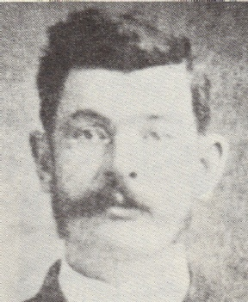  The Rev. E. F. J. Richter  1895 - 1897 | 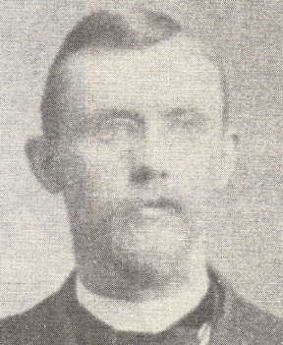  The Rev. M. Behrends  1897 - 1904 | 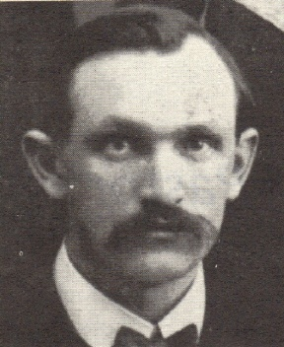  The Rev. August J. Wellner  1905 - 1922
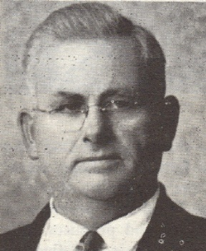  The Rev. Adolph H. Kilian  1922 - 1931 | 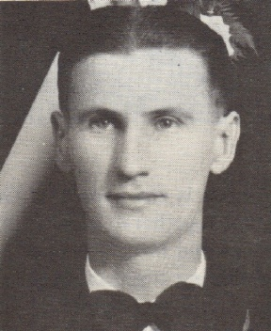  The Rev. C. P. Ringhand  1931 - 1932 | 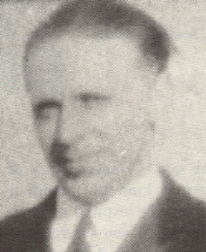  The Rev. A. R. Wacholz  1932 - 1935 | 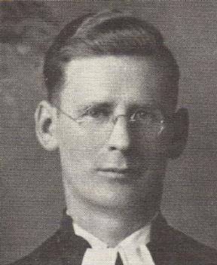  The Rev. J. H. Kolberg  1935 - 1942
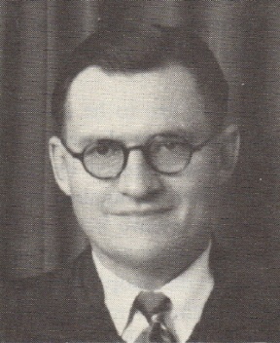  The Rev. John Mohr  1942 - 1944 | 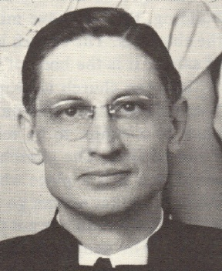  The Rev. H. J. Knoploh  1944 – 1948 | 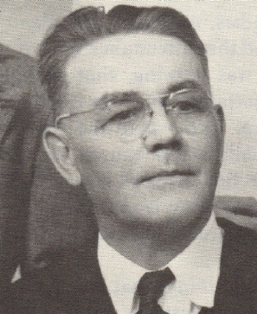  The Rev. Hugo Beyer  1948 - 1951 | 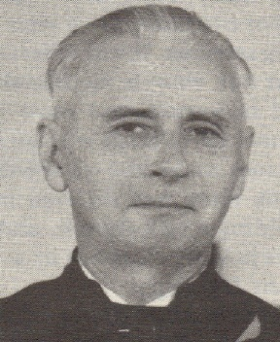  The Rev. E. R. Sommerfeld  1951 - 1958
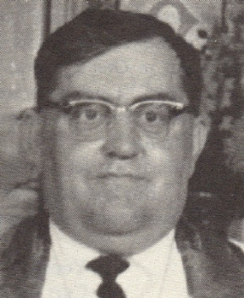  The Rev. John Jacklin  1958 - 1969 | 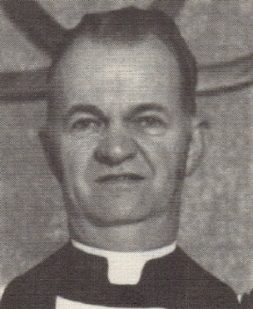  The Rev. Luther Flugstad  1969 - 1974 | 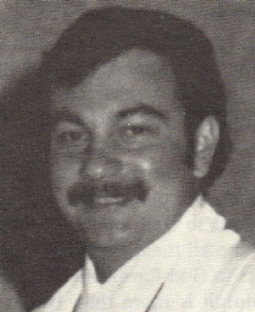  The Rev. Curt M. Joseph  1975 - 1981 | 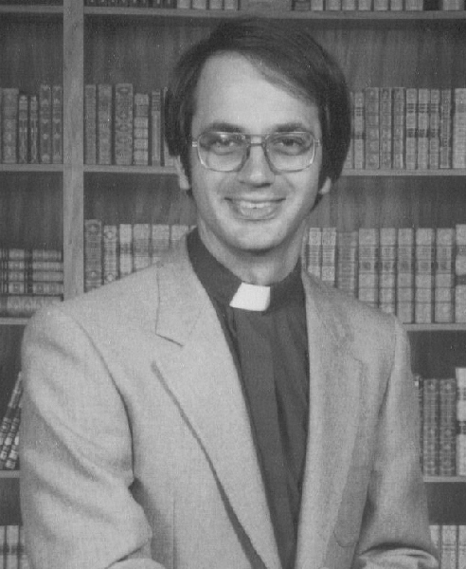  The Rev. Mark W. Smith  1982 - 1985
 | 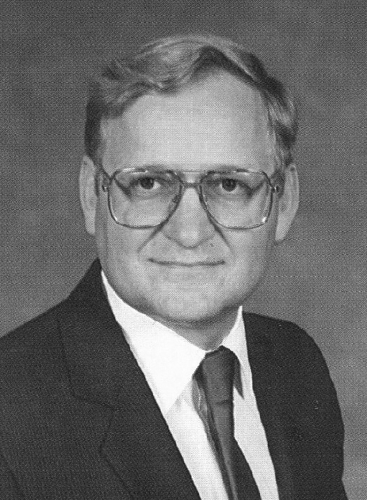  The Rev. Keith Klemm  1985-1997 | 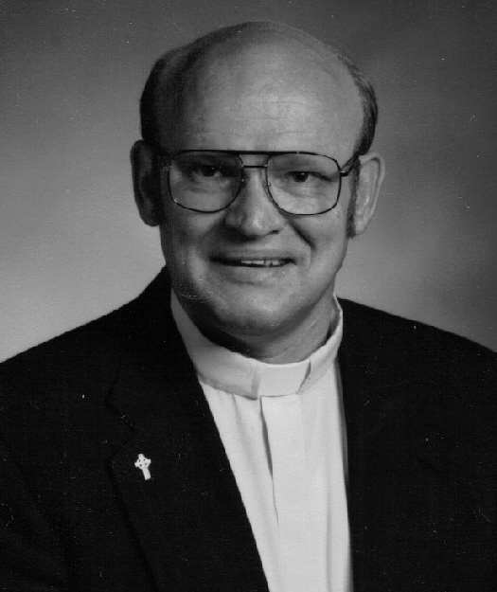  The Rev. Arlen Lloyd  1998 – 2006

